Instructions

First off, thanks so much for your interest in my design. I add new designs as often as my schedule allows to Threetoedbear.com. Check in if you’re looking for new ones or old ones, and occasionally I will add some of the designs I sell into the free section for a few days.
The material thickness this design was created for is 1/8 inch. If you requested a different size, the direction should all still apply.
There are 9 pieces in the original design of the moon crystal shelf:
- Back
- Front
- Middle Shelf
- Top Shelf
- Bottom Shelf
- Top Middle Shelf
- Bottom Middle Shelf
- Faceplate 1
- Faceplate 2

*Note: This is how I assembled the first shelf. There are several ways to go about it, this is meant to be more of a guide then instructions.

**Also, the instruction were made for the non-hanging version, so the pictures are off a little but the instructions are the same.

This is the back piece and the first piece in the assembly. Before inserting the shelve, put a light bead of glue on the inside of each notch (identified by each arrow).
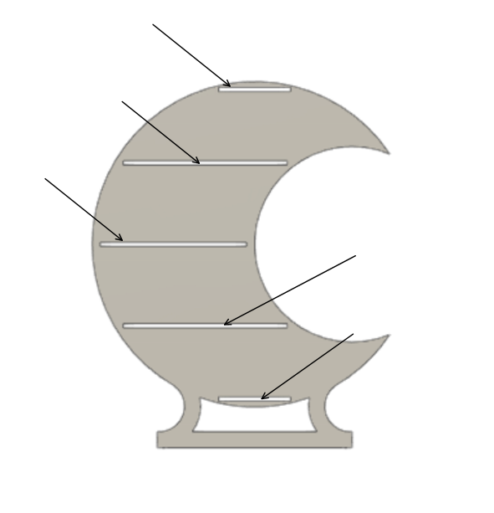
Back Piece
The shelves shall be inserted one-by-one into the proper slot. Insert the notch of each shelf into the slot of the back piece. The notch for each shelf are labelled below.
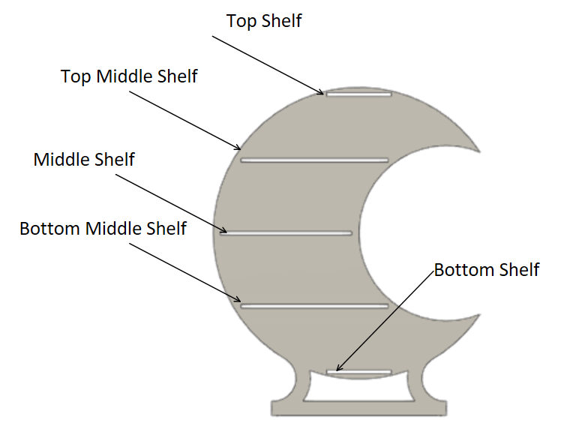
Back piece with labelled slots.

As the shelves are inserted, make sure they are aligned at a 90-degree angle with the back as shown below.
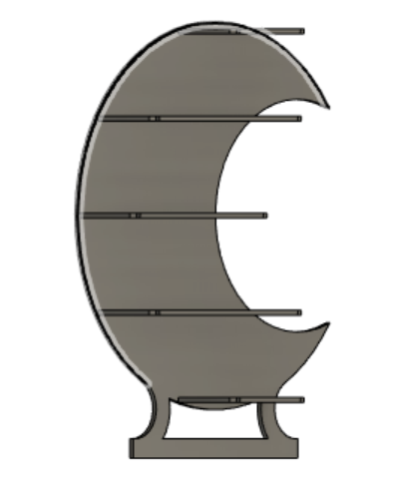
Side view of back with shelves

Wait for the glue to dry before proceeding. Then add a bead of glue to the inside of the slots on the front piece, similar to the way glue was applied to the back. Place the front on the shelves ensuring that slots of the shelves are inserted into the notched of the front piece.
Front Piece

Once the glue dries, the faceplates can be added. They get glued to the front piece to hide some notches and add character. The bigger faceplate will fit on the outside radius and the smaller will fit the inner radius. I suggest adding both at the same time to ensure proper alignment because they do flex.
